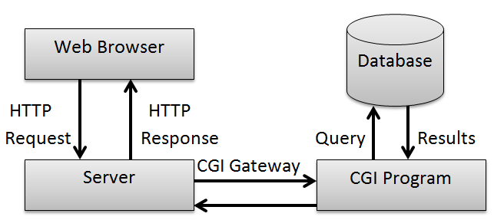

* The **common gateway interface (CGI)** is a standard way for a Web [server](https://whatis.techtarget.com/definition/server) to pass a Web user's request to an application program and to receive data back to forward to the user.
* When the user requests a Web page (for example, by clicking on a highlighted word or entering a Web site address), the server sends back the requested page.
* However, when a user fills out a form on a Web page and sends it in, it usually needs to be processed by an application program.

The Web server typically passes the form information to a small application program that processes the data and may send back a confirmation message.

This method or convention for passing data back and forth between the server and the application is called the common gateway interface (CGI).

* It is part of the Web's Hypertext Transfer Protocol ([HTTP](https://whatis.techtarget.com/definition/HTTP-Hypertext-Transfer-Protocol)).
* If you are creating a Web site and want a CGI application to get control, you specify the name of the application in the uniform resource locator ([URL](https://searchnetworking.techtarget.com/definition/URL)) that you code in an HTML file. This URL can be specified as part of the FORMS tags if you are creating a form. For example, you might code:

<FORM METHOD=”POST” ACTION=”http://www.mybiz.com/cgi-bin/formprog.pl”>

* and the server at "mybiz.com" would pass control to the CGI application called "formprog.pl" to record the entered data and return a confirmation message. (The ".pl" indicates a program written in [PERL](https://whatis.techtarget.com/definition/Perl) but other languages could have been used).
* The common gateway interface provides a consistent way for data to be passed from the user's request to the application program and back to the user.

This means that the person who writes the application program can makes sure it gets used no matter which operating system the server uses (PC, Macintosh, UNIX, OS/390, or others).

It's simply a basic way for information to be passed from the Web server about your request to the application program and back again.

* Because the interface is consistent, a programmer can write a CGI application in several different languages. The most popular languages for CGI applications are: [C](https://searchwindowsserver.techtarget.com/definition/C), [C++](https://searchsqlserver.techtarget.com/definition/C), [Java](https://www.theserverside.com/definition/Java), and [PERL](https://whatis.techtarget.com/definition/Perl).
* An alternative to a CGI application is Microsoft's [Active Server Page](https://searchwindowsserver.techtarget.com/definition/Active-Server-Page) (ASP), in which a [script](https://whatis.techtarget.com/definition/script) embedded in a Web page is executed at the server before the page is sent.